This is research I found on the web, that helped me create my diagram

**http://www.ibm.com/developerworks/rational/library/content/RationalEdge/sep04/bell/index.html**

**Structure diagrams in general**

As I have said, structure diagrams show the static structure of the system being modeled. focusing on the elements of a system, irrespective of time. Static structure is conveyed by showing the types and their instances in the system. Besides showing system types and their instances, structure diagrams also show at least some of the relationships among and between these elements and potentially even show their internal structure.

Structure diagrams are useful throughout the software lifecycle for a variety of team members. In general, these diagrams allow for design validation and design communication between individuals and teams. For example, business analysts can use class or object diagrams to model a business's current assets and resources, such as account ledgers, products, or geographic hierarchy. Architects can use the component and deployment diagrams to test/verify that their design is sound. Developers can use class diagrams to design and document the system's coded (or soon-to-be-coded) classes.

**The class diagram in particular**

UML 2 considers structure diagrams as a classification; there is no diagram itself called a "Structure Diagram." However, the class diagram offers a prime example of the structure diagram type, and provides us with an initial set of notation elements that all other structure diagrams use. And because the class diagram is so foundational, the remainder of this article will focus on the class diagram's notation set. By the end of this article you should have an understanding of how to draw a UML 2 class diagram and have a solid footing for understanding other structure diagrams when we cover them in later articles.

[**Back to top**](http://www.ibm.com/developerworks/rational/library/content/RationalEdge/sep04/bell/index.html#ibm-content)

**The basics**

As mentioned earlier, the purpose of the class diagram is to show the types being modeled within the system. In most UML models these types include:

* a class
* an interface
* a data type
* a component.

UML uses a special name for these types: "classifiers." Generally, you can think of a classifier as a class, but technically a classifier is a more general term that refers to the other three types above as well.

**Class name**

The UML representation of a class is a rectangle containing three compartments stacked vertically, as shown in Figure 1. The top compartment shows the class's name. The middle compartment lists the class's attributes. The bottom compartment lists the class's operations. When drawing a class element on a class diagram, you must use the top compartment, and the bottom two compartments are optional. (The bottom two would be unnecessary on a diagram depicting a higher level of detail in which the purpose is to show only the relationship between the classifiers.) Figure 1 shows an airline flight modeled as a UML class. As we can see, the name is *Flight*, and in the middle compartment we see that the Flight class has three attributes: flightNumber, departureTime, and flightDuration. In the bottom compartment we see that the Flight class has two operations: delayFlight and getArrivalTime.

**Figure 1: Class diagram for the class Flight**

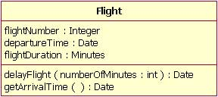

**Class attribute list**

The attribute section of a class (the middle compartment) lists each of the class's attributes on a separate line. The attribute section is optional, but when used it contains each attribute of the class displayed in a list format. The line uses the following format:

name : attribute type

flightNumber : Integer

Continuing with our Flight class example, we can describe the class's attributes with the attribute type information, as shown in Table 1.

**Table 1: The Flight class's attribute names with their associated types**

| **Attribute Name** | **Attribute Type** |
| --- | --- |
| flightNumber | Integer |
| departureTime | Date |
| flightDuration | Minutes |

In business class diagrams, the attribute types usually correspond to units that make sense to the likely readers of the diagram (i.e., minutes, dollars, etc.). However, a class diagram that will be used to generate code needs classes whose attribute types are limited to the types provided by the programming language, or types included in the model that will also be implemented in the system.

Sometimes it is useful to show on a class diagram that a particular attribute has a default value. (For example, in a banking account application a new bank account would start off with a zero balance.) The UML specification allows for the identification of default values in the attribute list section by using the following notation:

name : attribute type = default value

For example:

balance : Dollars = 0

Showing a default value for attributes is optional; Figure 2 shows a Bank Account class with an attribute called *balance*, which has a default value of 0.

**Figure 2: A Bank Account class diagram showing the balance attribute's value defaulted to zero dollars**

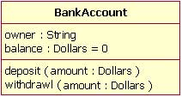

**Class operations list**

The class's operations are documented in the third (lowest) compartment of the class diagram's rectangle, which again is optional. Like the attributes, the operations of a class are displayed in a list format, with each operation on its own line. Operations are documented using the following notation:

name(parameter list) : type of value returned

The Flight class's operations are mapped in Table 2 below.

**Table 2: Flight class's operations mapped from Figure 3**

| **Operation Name** | **Parameters Return** | **Value Type** |
| --- | --- | --- |
| delayFlight | | **Name** | **Type** | | --- | --- | | numberOfMinutes | Minutes | | N/A |
| getArrivalTime | N/A | Date |

Figure 3 shows that the delayFlight operation has one input parameter — numberOfMinutes — of the type Minutes. However, the delayFlight operation does not have a return value. [Note: The delayFlight does not have a return value because I made a design decision not to have one. One could argue that the delay operation should return the new arrival time, and if this were the case, the operation signature would appear asdelayFlight(numberOfMinutes : Minutes) : Date.] When an operation has parameters, they are put inside the operation's parentheses; each parameter uses the format "parameter name : parameter type".

**Figure 3: The Flight class operations parameters include the optional "in" marking**

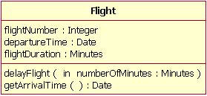

When documenting an operation's parameters, you may use an optional indicator to show whether or not the parameter is input to, or output from, the operation. This optional indicator appears as an "in" or "out" as shown in the operations compartment in Figure 3. Typically, these indicators are unnecessary unless an older programming language such as Fortran will be used, in which case this information can be helpful. However, in C++ and Java, all parameters are "in" parameters and since "in" is the parameter's default type according to the UML specification, most people will leave out the input/output indicators.

**Inheritance**

A very important concept in object-oriented design, *inheritance*, refers to the ability of one class (child class) to *inherit* the identical functionality of another class (super class), and then add new functionality of its own. (In a very non-technical sense, imagine that I inherited my mother's general musical abilities, but in my family I'm the only one who plays electric guitar.) To model inheritance on a class diagram, a solid line is drawn from the child class (the class inheriting the behavior) with a closed, unfilled arrowhead (or triangle) pointing to the super class. Consider types of bank accounts: Figure 4 shows how both CheckingAccount and SavingsAccount classes inherit from the BankAccount class.

**Figure 4: Inheritance is indicated by a solid line with a closed, unfilled arrowhead pointing at the super class**

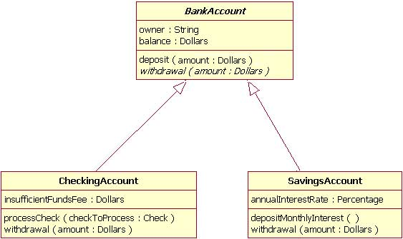

In Figure 4, the inheritance relationship is drawn with separate lines for each subclass, which is the method used in IBM Rational Rose and IBM Rational XDE. However, there is an alternative way to draw inheritance called *tree notation*. You can use tree notation when there are two or more child classes, as in Figure 4, except that the inheritance lines merge together like a tree branch. Figure 5 is a redrawing of the same inheritance shown in Figure 4, but this time using tree notation.

**Figure 5: An example of inheritance using tree notation**

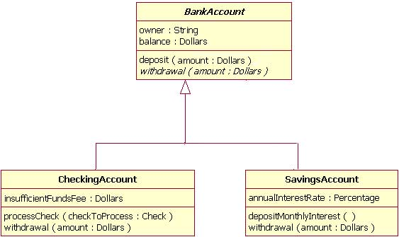

**Abstract classes and operations**

The observant reader will notice that the diagrams in Figures 4 and 5 use italicized text for the BankAccount class name and withdrawal operation. This indicates that the BankAccount class is an abstract class and the withdrawal method is an abstract operation. In other words, the BankAccount class provides the abstract operation signature of withdrawal and the two child classes of CheckingAccount and SavingsAccount each implement their own version of that operation.

However, super classes (parent classes) do not have to be abstract classes. It is normal for a standard class to be a super class.

**Associations**

When you model a system, certain objects will be related to each other, and these relationships themselves need to be modeled for clarity. There are five types of associations. I will discuss two of them — bi-directional and uni-directional associations — in this section, and I will discuss the remaining three association types in the *Beyond the basics* section. Please note that a detailed discussion of when to use each type of association is beyond the scope of this article. Instead, I will focus on the purpose of each association type and show how the association is drawn on a class diagram.

**Bi-directional (standard) association**

An association is a linkage between two classes. Associations are always assumed to be bi-directional; this means that both classes are aware of each other and their relationship, unless you qualify the association as some other type. Going back to our Flight example, Figure 6 shows a standard kind of association between the Flight class and the Plane class.

**Figure 6: An example of a bi-directional association between a Flight class and a Plane class**

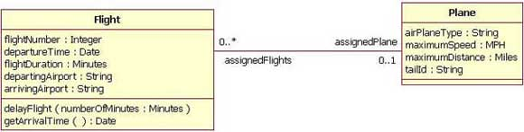

A bi-directional association is indicated by a solid line between the two classes. At either end of the line, you place a role name and a multiplicity value. Figure 6 shows that the Flight is associated with a specific Plane, and the Flight class knows about this association. The Plane takes on the role of "assignedPlane" in this association because the role name next to the Plane class says so. The multiplicity value next to the Plane class of 0..1 means that when an instance of a Flight exists, it can either have one instance of a Plane associated with it or no Planes associated with it (i.e., maybe a plane has not yet been assigned). Figure 6 also shows that a Plane knows about its association with the Flight class. In this association, the Flight takes on the role of "assignedFlights"; the diagram in Figure 6 tells us that the Plane instance can be associated either with no flights (e.g., it's a brand new plane) or with up to an infinite number of flights (e.g., the plane has been in commission for the last five years).

For those wondering what the potential multiplicity values are for the ends of associations, Table 3 below lists some example multiplicity values along with their meanings.

**Table 3: Multiplicity values and their indicators**

| **Indicator** | **Meaning** |
| --- | --- |
| 0..1 | Zero or one |
| 1 | One only |
| 0..* | Zero or more |
| * | Zero or more |
| 1..* | One or more |
| 3 | Three only |
| 0..5 | Zero to Five |
| 5..15 | Five to Fifteen |
| Potential Multiplicity Values | |

**Uni-directional association**

In a uni-directional association, two classes are related, but only one class knows that the relationship exists. Figure 7 shows an example of an overdrawn accounts report with a uni-directional association.

**Figure 7: An example of a uni-directional association: The OverdrawnAccountsReport class knows about the BankAccount class, but the BankAccount class does not know about the association**

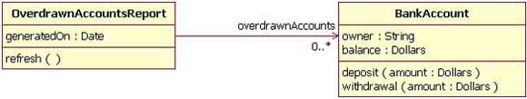

A uni-directional association is drawn as a solid line with an open arrowhead (not the closed arrowhead, or triangle, used to indicate inheritance) pointing to the known class. Like standard associations, the uni-directional association includes a role name and a multiplicity value, but unlike the standard bi-directional association, the uni-directional association only contains the role name and multiplicity value for the known class. In our example in Figure 7, the OverdrawnAccountsReport knows about the BankAccount class, and the BankAccount class plays the role of "overdrawnAccounts." However, unlike a standard association, the BankAccount class has no idea that it is associated with the OverdrawnAccountsReport. [Note: It may seem strange that the BankAccount class does not know about the OverdrawnAccountsReport class. This modeling allows report classes to know about the business class they report, but the business classes do not know they are being reported on. This loosens the coupling of the objects and therefore makes the system more adaptive to changes.]

**Packages**

Inevitably, if you are modeling a large system or a large area of a business, there will be many different classifiers in your model. Managing all the classes can be a daunting task; therefore, UML provides an organizing element called a *package*. Packages enable modelers to organize the model's classifiers into namespaces, which is sort of like folders in a filing system. Dividing a system into multiple packages makes the system easier to understand, especially if each package represents a specific part of the system. [Note: Packages are great for organizing your model's classes, but it's important to remember that your class diagrams are supposed to easily communicate information about the system being modeled. In cases where your packages have lots of classes, it is better to use multiple topic-specific class diagrams instead of just producing one large class diagram.]

There are two ways of drawing packages on diagrams. There is no rule for determining which notation to use, except to use your personal judgement regarding which is easiest to read for the class diagram you are drawing. Both ways begin with a large rectangle with a smaller rectangle (tab) above its upper left corner, as seen in Figure 8. But the modeler must decide how the package's membership is to be shown, as follows:

* If the modeler decides to show the package's members within the large rectangle, then all those members need to be placed within the rectangle. [Note: It's important to understand that when I say "all those members," I mean only the classes that the current diagram is going to show. A diagram showing a package with contents does not need to show all its contents; it can show a subset of the contained elements according to some criterion, which is not necessarily all the package's classifiers.] Also the package's name needs to be placed in the package's smaller rectangle (as show n in Figure 8).
* If the modeler decides to show the package's members outside the large rectangle then all the members that will be shown on the diagram need to be placed outside the rectangle. To show what classifiers belong to the package, a line is drawn from each classifier to a circle that has a plus sign inside the circle attached to the package (Figure 9).

**Figure 8: An example package element that shows its members inside the package's rectangle boundaries**

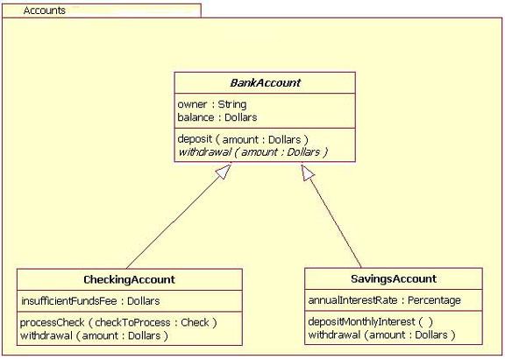

**Figure 9: An example package element showing its membership via connected lines**

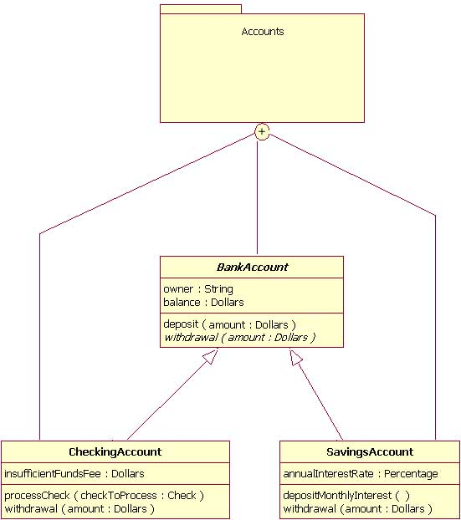

**Importance of understanding the basics**

It is more important than ever in UML 2 to understand the basics of the class diagram. This is because the class diagram provides the basic building blocks for all other structure diagrams, such as the component or object diagrams (just to name a few).

[**Back to top**](http://www.ibm.com/developerworks/rational/library/content/RationalEdge/sep04/bell/index.html#ibm-content)

**Beyond the basics**

At this point, I have covered the basics of the class diagram, but do not stop reading yet! In the following sections, I will address more important aspects of the class diagram that you can put to good use. These include interfaces, the three remaining types of associations, visibility, and other additions in the UML 2 specification.

**Interfaces**

Earlier in this article, I suggested that you think of *classifiers* simply as classes. In fact, a classifier is a more general concept, which includes data types and interfaces.

A complete discussion of when and how to use data types and interfaces effectively in a system's structure diagrams is beyond the scope of this article. So why do I mention data types and interfaces here? There are times when you might want to model these classifier types on a structure diagram, and it is important to use the proper notation in doing so, or at least be aware of these classifier types. Drawing these classifiers incorrectly will likely confuse readers of your structure diagram, and the ensuing system will probably not meet requirements.

A class and an interface differ: A class can have an actual instance of its type, whereas an interface must have at least one class to implement it. In UML 2, an interface is considered to be a specialization of a class modeling element. Therefore, an interface is drawn just like a class, but the top compartment of the rectangle also has the text "«interface»", as shown in Figure 10. [Note: When drawing a class diagram it is completely within UML specification to put «class» in the top compartment of the rectangle, as you would with «interface»; however, the UML specification says that placing the "class" text in this compartment is optional, and it should be assumed if «class» is not displayed.]

**Figure 10: Example of a class diagram in which the Professor and Student classes implement the Person interface**

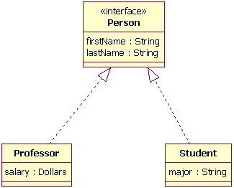

In the diagram shown in Figure 10, both the Professor and Student classes implement the Person interface and do not inherit from it. We know this for two reasons: 1) The Person object is defined as an interface — it has the "«interface»" text in the object's name area, and we see that the Professor and Student objects are *class* objects because they are labeled according to the rules for drawing a class object (there is no additional classification text in their name area). 2) We know inheritance is not being shown here, because the line with the arrow is dotted and not solid. As shown in Figure 10, a *dotted* line with a closed, unfilled arrow means realization (or implementation); as we saw in Figure 4, a *solid* arrow line with a closed, unfilled arrow means inheritance.

**More associations**

Above, I discussed bi-directional and uni-directional associations. Now I will address the three remaining types of associations.

**Association class**

In modeling an association, there are times when you need to include another class because it includes valuable information about the relationship. For this you would use an *association class* that you tie to the primary association. An association class is represented like a normal class. The difference is that the association line between the primary classes intersects a dotted line connected to the association class. Figure 11 shows an association class for our airline industry example.

**Figure 11: Adding the association class MileageCredit**

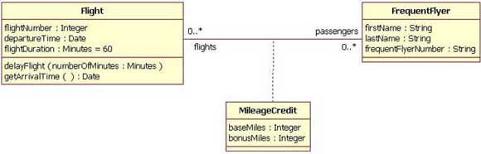

In the class diagram shown in Figure 11, the association between the Flight class and the FrequentFlyer class results in an association class called MileageCredit. This means that when an instance of a Flight class is associated with an instance of a FrequentFlyer class, there will also be an instance of a MileageCredit class.

**Aggregation**

Aggregation is a special type of association used to model a "whole to its parts" relationship. In basic aggregation relationships, the lifecycle of a *part*class is independent from the *whole* class's lifecycle.

For example, we can think of *Car* as a whole entity and *Car Wheel* as part of the overall Car. The wheel can be created weeks ahead of time, and it can sit in a warehouse before being placed on a car during assembly. In this example, the Wheel class's instance clearly lives independently of the Car class's instance. However, there are times when the *part* class's lifecycle *is not* independent from that of the *whole* class — this is called composition aggregation. Consider, for example, the relationship of a company to its departments. Both *Company and Departments* are modeled as classes, and a department cannot exist before a company exists. Here the Department class's instance is dependent upon the existence of the Company class's instance.

Let's explore basic aggregation and composition aggregation further.

**Basic aggregation**  
An association with an aggregation relationship indicates that one class is a part of another class. In an aggregation relationship, the child class instance can outlive its parent class. To represent an aggregation relationship, you draw a solid line from the parent class to the part class, and draw an unfilled diamond shape on the parent class's association end. Figure 12 shows an example of an aggregation relationship between a Car and a Wheel.

**Figure 12: Example of an aggregation association**

Example of an aggregation association

**Composition aggregation**  
The composition aggregation relationship is just another form of the aggregation relationship, but the child class's instance lifecycle is dependent on the parent class's instance lifecycle. In Figure 13, which shows a composition relationship between a Company class and a Department class, notice that the composition relationship is drawn like the aggregation relationship, but this time the diamond shape is filled.

**Figure 13: Example of a composition relationship**

Example of a composition relationship

In the relationship modeled in Figure 13, a Company class instance will always have at least one Department class instance. Because the relationship is a composition relationship, when the Company instance is removed/destroyed, the Department instance is automatically removed/destroyed as well. Another important feature of composition aggregation is that the part class can only be related to one instance of the parent class (e.g. the Company class in our example).

**Reflexive associations**

We have now discussed all the association types. As you may have noticed, all our examples have shown a relationship between two different classes. However, a class can also be associated with itself, using a reflexive association. This may not make sense at first, but remember that classes are abstractions. Figure 14 shows how an Employee class could be related to itself through the manager/manages role. When a class is associated to itself, this does not mean that a class's instance is related to itself, but that an instance of the class is related to another instance of the class.

**Figure 14: Example of a reflexive association relationship**

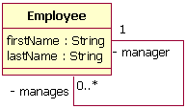

The relationship drawn in Figure 14 means that an instance of Employee can be the manager of another Employee instance. However, because the relationship role of "manages" has a multiplicity of 0..*; an Employee might not have any other Employees to manage.

**Visibility**

In object-oriented design, there is a notation of visibility for attributes and operations. UML identifies four types of visibility: public, protected, private, and package.

The UML specification does not require attributes and operations visibility to be displayed on the class diagram, but it does require that it be defined for each attribute or operation. To display visibility on the class diagram, you place the visibility mark in front of the attribute's or operation's name. Though UML specifies four visibility types, an actual programming language may add additional visibilities, or it may not support the UML-defined visibilities. Table 4 displays the different marks for the UML-supported visibility types.

**Table 4: Marks for UML-supported visibility types**

| **Mark** | **Visibility type** |
| --- | --- |
| + | Public |
| # | Protected |
| - | Private |
| ~ | Package |

Now, let's look at a class that shows the visibility types indicated for its attributes and operations. In Figure 15, all the attributes and operations are public, with the exception of the updateBalance operation. The updateBalance operation is protected.

**Figure 15: A BankAccount class that shows the visibility of its attributes and operations**

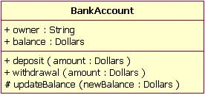

[**Back to top**](http://www.ibm.com/developerworks/rational/library/content/RationalEdge/sep04/bell/index.html#ibm-content)

**UML 2 additions**

Now that we have covered the basics and the advanced topics, we will cover some of the new notations added to the class diagram from UML 1.x.

**Instances**

When modeling a system's structure it is sometimes useful to show example instances of the classes. To model this, UML 2 provides the *instance specification* element, which shows interesting information using example (or real) instances in the system.

The notation of an instance is the same as a class, but instead of the top compartment merely having the class's name, the name is an underlined concatenation of:

Instance Name : Class Name

For example:

Donald : Person

Because the purpose of showing instances is to show interesting or relevant information, it is not necessary to include in your model the entire instance's attributes and operations. Instead it is completely appropriate to show only the attributes and their values that are interesting as depicted in Figure 16.

**Figure 16: An example instance of a Plane class (only the interesting attribute values are shown)**

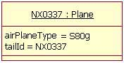

However, merely showing some instances without their relationship is not very useful; therefore, UML 2 allows for the modeling of the relationships/associations at the instance level as well. The rules for drawing associations are the same as for normal class relationships, although there is one additional requirement when modeling the associations. The additional restriction is that association relationships must match the class diagram's relationships and therefore the association's role names must also match the class diagram. An example of this is shown in Figure 17. In this example the instances are example instances of the class diagram found in Figure 6.

**Figure 17: An example of Figure 6 using instances instead of classes**

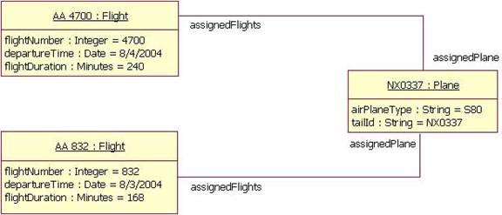

Figure 17 has two instances of the Flight class because the class diagram indicated that the relationship between the Plane class and the Flight class is *zero-to-many*. Therefore, our example shows the two Flight instances that the NX0337 Plane instance is related to.

**Roles**

Modeling the instances of classes is sometimes more detailed than one might wish. Sometimes, you may simply want to model a class's relationship at a more generic level. In such cases, you should use the *role* notation. The role notation is very similar to the instances notation. To model a class's role, you draw a box and place the class's role name and class name inside as with the instances notation, but in this case you do not underline the words. Figure 18 shows an example of the roles played by the Employee class described by the diagram at Figure 14. In Figure 18, we can tell, even though the Employee class is related to itself, that the relationship is really between an Employee playing the role of manager and an Employee playing the role of team member.

**Figure 18: A class diagram showing the class in Figure 14 in its different roles**

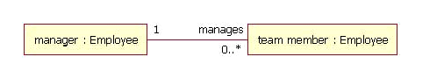

Note that you cannot model a class's role on a plain class diagram, even though Figure 18 makes it appear that you can. In order to use the role notation you will need to use the Internal Structure notation, discussed next.

**Internal Structures**

One of the more useful features of UML 2 structure diagrams is the new internal structure notation. It allows you to show how a class or another classifier is internally composed. This was not possible in UML 1.x, because the notation set limited you to showing only the aggregation relationships that a class had. Now, in UML 2, the internal structure notation lets you more clearly show how that class's parts relate to each other.

Let's look at an example. In Figure 18 we have a class diagram showing how a Plane class is composed of four engines and two control software objects. What is missing from this diagram is any information about how airplane parts are assembled. From the diagram in Figure 18, you cannot tell if the control software objects control two engines each, or if one control software object controls three engines and the other controls one engine.

**Figure 19: A class diagram that only shows relationships between the objects**

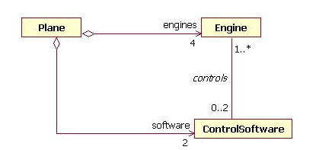

Drawing a class's internal structure will improve this situation. You start by drawing a box with two compartments. The top compartment contains the class name, and the lower compartment contains the class's internal structure, showing the parent class's part classes in their respective roles, as well as how each particular class relates to others in that role. Figure 19 shows the internal structure of Plane class; notice how the internal structure clears up the confusion.

**Figure 20: An example internal structure of a Plane class**

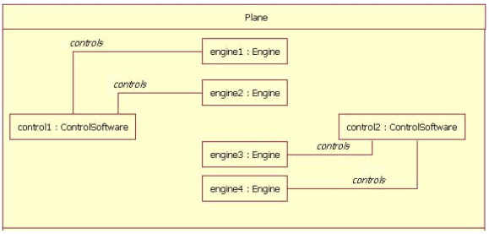

In Figure 20 the Plane has two ControlSoftware objects and each one controls two engines. The ControlSoftware on the left side of the diagram (control1) controls engines 1 and 2. The ControlSoftware on the right side of the diagram (control2) controls engines 3 and 4.

[**Back to top**](http://www.ibm.com/developerworks/rational/library/content/RationalEdge/sep04/bell/index.html#ibm-content)

**Conclusion**

There are at least two important reasons for understanding the class diagram. The first is that it shows the static structure of classifiers in a system; the second reason is that the diagram provides the basic notation for other structure diagrams prescribed by UML. Developers will think the class diagram was created specially for them; but other team members will find them useful, too. Business analysts can use class diagrams to model systems from the business perspective. As we will see in other articles in this series on UML basics, other diagrams — including the activity, sequence, and statechart diagrams — refer to the classes modeled and documented on the class diagram.

**1.****Conceptual Class Diagrams**

[Figure 1](http://www.agilemodeling.com/artifacts/classDiagram.htm#Figure1Sketch) depicts a start at a simple UML class diagram for the conceptual model for a university. Classes are depicted as boxes with three sections, the top one indicates the name of the class, the middle one lists the attributes of the class, and the third one lists the methods. By including both an attribute and a method box in the class I'm arguably making design decisions in my model, something I shouldn't be doing if my goal is conceptual modeling. Another approach would be to have two sections, one for the name and one listing responsibilities. This would be closer to a [CRC model](http://agilemodeling.com/artifacts/crcModel.htm) (so if I wanted to take this sort of approach I'd use CRC cards instead of a UML class diagram). I could also use class boxes that show just the name of the class, enabling me to focus on just the classes and their relationships. However, if that was my goal I'd be more likely to create an [ORM diagram](http://agilemodeling.com/artifacts/ormDiagram.htm) instead. In short, I prefer to follow AM's [*Apply the Right Artifact(s)*](http://agilemodeling.com/practices.htm#ApplyTheRightArtifacts) practice and use each modeling technique for what it's best at.

**Figure 1. Sketch of a conceptual class diagram.**

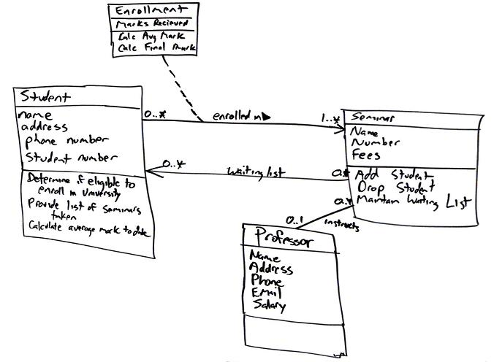

*Enrollment* is an associative class, also called a link class, which is used to model associations that have methods and attributes. Associative classes are typically modeled during analysis and then refactored into what I show in [Figure 2](http://www.agilemodeling.com/artifacts/classDiagram.htm#Figure2ConceptualDiagram) during design ([Figure 2](http://www.agilemodeling.com/artifacts/classDiagram.htm#Figure2ConceptualDiagram) is still a conceptual diagram, albeit one with a design flavor to it). To date, at least to my knowledge, no mainstream programming language exists that supports the notion of associations that have responsibilities. Because you can directly build your software in this manner, I have a tendency to stay away from using association classes and instead resolve them during my analysis efforts. This is not a purist way to model, but it is pragmatic because the other members on the team, including project stakeholders, don't need to learn the notation and concepts behind associative classes.

[Figure 2](http://www.agilemodeling.com/artifacts/classDiagram.htm#Figure2ConceptualDiagram) depicts a reworked version of [Figure 1](http://www.agilemodeling.com/artifacts/classDiagram.htm#Figure1Sketch), the associative class has been resolved. I could have added an attribute in the *Seminar* class called *Waiting List* but, instead, chose to model it as an association because that is what it actually represents: that seminar objects maintain a waiting list of zero or more student objects. Attributes and associations are both properties in the UML 2.0 so they're treated as basically the same sort of thing. I also showed associations are implemented as a combination of attributes and operations - I prefer to keep my models simple and assume that the attributes and operations exist to implement the associations. Furthermore that would be a detailed design issue anyway, something that isn't appropriate on a conceptual model.

**Figure 2. Initial conceptual class diagram.**

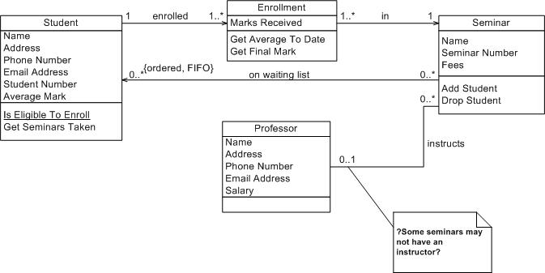

The *on* *waiting list* association is unidirectional because there isn't yet a need for collaboration in both directions. Follow the AM practice of [*Create Simple Content*](http://agilemodeling.com/practices.htm#CreateSimpleContent) and don't over model - you don't need a bi-directional association right now so don't model it. The *enrolled in* association between the *Student* and *Enrollment* classes is also uni-directional for similar reasons. For this association it appears student objects know what enrollment records they are involved with, recording the seminars they have taken in the past, as well as the seminars in which they are currently involved. This association would be traversed to calculate their student object's average mark and to provide information about seminars taken. There is also an *enrolled in* association between *Enrollment* and *Seminar* to support the capability for student objects to produce a list of seminars taken. The*instructs* association between the *Professor* class and the *Seminar* class is bidirectional because professor objects know what seminars they instruct and seminar objects know who instruct them.

When I'm conceptual modeling my style is to name attributes and methods using the formats *Attribute Name* and *Method Name*, respectively. Following a consistent and sensible naming convention helps to make your diagrams readable, an important benefit of AM's [*Apply Modeling Standards*](http://agilemodeling.com/practices.htm#ApplyModelingStandards) practice. Also notice in [Figure 2](http://www.agilemodeling.com/artifacts/classDiagram.htm#Figure2ConceptualDiagram) how I haven't modeled the visibility of the attributes and methods to any great extent. Visibility is an important issue during design but, for now, it can be ignored. Also notice I haven't defined the full method signatures for the classes. This is another task I typically leave to design.

I was able to determine with certainty, based on this information, the multiplicities for all but one association and for that one I marked it with a note so I know to discuss it further with my stakeholders. Notice my use of question marks in the note. My style is to mark unknown information on my diagrams this way to remind myself that I need to look into it.

In [Figure 2](http://www.agilemodeling.com/artifacts/classDiagram.htm#Figure2ConceptualDiagram) I modeled a UML constraint, in this case *{ordered FIFO}* on the association between *Seminar* and *Student*. The basic idea is that students are put on the waiting list on a first-come, first-served/out (FIFO) basis. In other words, the students are put on the waiting list in order. UML constraints are used to model complex and/or important information accurately in your UML diagrams. UML constraints are modeled using the format “{constraint description}” format, where the constraint description may be in any format, including predicate calculus. My preference is to use UML notes with English comments, instead of formal constraints, because they're easier to read.

**2.****Design Class Diagrams**

Coming soon

**Figure 3. A design class diagram.**

**3.****How to Create Class Diagrams**

To create and evolve a conceptual class diagram, you need to iteratively model:

* [Classes](http://www.agilemodeling.com/artifacts/classDiagram.htm#Classes)
* [Responsibilities](http://www.agilemodeling.com/artifacts/classDiagram.htm#Responsibilities)
* [Associations](http://www.agilemodeling.com/artifacts/classDiagram.htm#Associations)
* [Inheritance relationships](http://www.agilemodeling.com/artifacts/classDiagram.htm#InheritanceRelationships)
* [Composition associations](http://www.agilemodeling.com/artifacts/classDiagram.htm#CompositionAssociations)
* [Vocabularies](http://www.agilemodeling.com/artifacts/classDiagram.htm#Vocabularies)

To create and evolve a design class diagram, you need to iteratively model:

* [Classes](http://www.agilemodeling.com/artifacts/classDiagram.htm#Classes)
* [Responsibilities](http://www.agilemodeling.com/artifacts/classDiagram.htm#Responsibilities)
* [Associations](http://www.agilemodeling.com/artifacts/classDiagram.htm#Associations)
* [Inheritance relationships](http://www.agilemodeling.com/artifacts/classDiagram.htm#InheritanceRelationships)
* [Composition associations](http://www.agilemodeling.com/artifacts/classDiagram.htm#CompositionAssociations)
* Interfaces

**3.1****Classes**

An object is any person, place, thing, concept, event, screen, or report applicable to your system. Objects both know things (they have attributes) and they do things (they have methods). A class is a representation of an object and, in many ways, it is simply a template from which objects are created. Classes form the main building blocks of an object-oriented application. Although thousands of students attend the university, you would only model one class, called *Student*, which would represent the entire collection of students.

**3.2****Responsibilities**

Classes are typically modeled as rectangles with three sections: the top section for the name of the class, the middle section for the attributes of the class, and the bottom section for the methods of the class. The initial classes of your model can be identified in the same manner as they are when you are [CRC modeling](http://agilemodeling.com/artifacts/crcModel.htm), as will the initial responsibilities (its attributes and methods). Attributes are the information stored about an object (or at least information temporarily maintained about an object), while methods are the things an object or class do. For example, students have student numbers, names, addresses, and phone numbers. Those are all examples of the attributes of a student. Students also enroll in courses, drop courses, and request transcripts. Those are all examples of the things a student does, which get implemented (coded) as methods. You should think of methods as the object-oriented equivalent of functions and procedures.

An important consideration the appropriate level of detail. Consider the *Student* class modeled in [Figure 2](http://www.agilemodeling.com/artifacts/classDiagram.htm#Figure2ConceptualDiagram) which has an attribute called *Address*. When you stop and think about it, addresses are complicated things. They have complex data, containing street and city information for example, and they potentially have behavior. An arguably better way to model this is depicted in [Figure 4](http://www.agilemodeling.com/artifacts/classDiagram.htm#Figure4StudentAddress). Notice how the *Address* class has been modeled to include an attribute for each piece of data it comprises and two methods have been added: one to verify it is a valid address and one to output it as a label (perhaps for an envelope). By introducing the *Address* class, the *Student* class has become more cohesive. It no longer contains logic (such as validation) that is pertinent to addresses. The *Address* class could now be reused in other places, such as the *Professor* class, reducing your overall development costs. Furthermore, if the need arises to support students with several addresses-during the school term, a student may live in a different location than his permanent mailing address, such as a dorm-information the system may need to track. Having a separate class to implement addresses should make the addition of this behavior easier to implement.

**Figure 4. Student and address (Conceptual class diagram).**

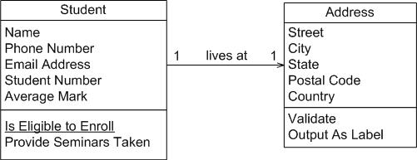

An interesting feature of the *Student* class is its *Is Eligible to Enroll* responsibility. The underline indicates that this is a class-level responsibility, not an instance-level responsibility (for example *Provide Seminars Taken*). A good indication that a responsibility belongs at the class level is one that makes sense that it belongs to the class but that doesn't apply to an individual object of that class. In this case this operation implements BR129*Determine Eligibility to Enroll* called out in the [*Enroll in Seminar* system use case](http://agilemodeling.com/artifacts/systemUseCase.htm#Figure1).

The *Seminar* class of [Figure 2](http://www.agilemodeling.com/artifacts/classDiagram.htm#Figure2ConceptualDiagram) is refactored into the classes depicted in [Figure 5](http://www.agilemodeling.com/artifacts/classDiagram.htm#Figure5SeminarNormalized). Refactoring such as this is called class normalization ([Ambler 2004](http://www.ambysoft.com/agileDatabaseTechniques.html)), a process in which you refactor the behavior of classes to increase their cohesion and/or to reduce the coupling between classes. A seminar is an offering of a course, for example, there could be five seminar offerings of the course "CSC 148 Introduction to Computer Science." The attributes*name* and *fees* where moved to the *Course* class and *courseNumber* was introduced. The *getFullName()* method concatenates the course number, "CSC 148" and the course name "Introduction to Computer Science" to give the full name of the course. This is called a getter method, an operation that returns a data value pertinent to an object. Although getter methods, and the corresponding setter methods, need to be developed for a class they are typically assumed to exist and are therefore not modeled (particularly on conceptual class diagrams) to not clutter your models.

**Figure 5. Seminar normalized (Conceptual class diagram).**

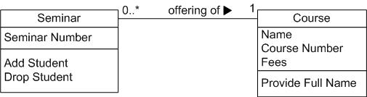

[Figure 6](http://www.agilemodeling.com/artifacts/classDiagram.htm#Figure6Course) depicts *Course* from [Figure 5](http://www.agilemodeling.com/artifacts/classDiagram.htm#Figure5SeminarNormalized) as it would appear with its getter and setter methods modeled. Getters and setters are details that are not appropriate for conceptual models and in my experience aren't even appropriate for detailed design diagrams - instead I would set a coding guideline that all properties will have getter and setter methods and leave it at that. Some people do choose to model getters and setters but I consider them visual noise that clutter your diagrams without adding value.

**Figure 6. Course with accessor methods (Inching towards a design class diagram).**

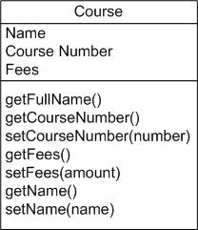

**3.3****Associations**

Objects are often associated with, or related to, other objects. For example, as you see in Figure 2 several associations exist: Students are ON WAITING LIST for seminars, professors INSTRUCT seminars, seminars are an OFFERING OF courses, a professor LIVES AT an address, and so on. Associations are modeled as lines connecting the two classes whose instances (objects) are involved in the relationship.

When you model associations in UML class diagrams, you show them as a thin line connecting two classes, as you see in [Figure 6](http://www.agilemodeling.com/artifacts/classDiagram.htm#Figure6AssociationNotation). Associations can become quite complex; consequently, you can depict some things about them on your diagrams. The label, which is optional, although highly recommended, is typically one or two words describing the association. For example, professors instruct seminars.

**Figure 6. Notation for associations.**

http://agilemodeling.com/images/models/classDiagramAssocationNotation.jpg

It is not enough simply to know professors instruct seminars. How many seminars do professors instruct? None, one, or several? Furthermore, associations are often two-way streets: not only do professors instruct seminars, but also seminars are instructed by professors. This leads to questions like: how many professors can instruct any given seminar and is it possible to have a seminar with no one instructing it? The implication is you also need to identify the multiplicity of an association. The multiplicity of the association is labeled on either end of the line, one multiplicity indicator for each direction ([Table 1](http://www.agilemodeling.com/artifacts/classDiagram.htm#Table1MultiplicityIndicators) summarizes the potential multiplicity indicators you can use).

**Table 1. Multiplicity Indicators.**

|  |  |
| --- | --- |
| **Indicator** | **Meaning** |
| 0..1 | Zero or one |
| 1 | One only |
| 0..* | Zero or more |
| 1..* | One or more |
| n | Only *n* (where *n* > 1) |
| 0..n | Zero to *n* (where *n* > 1) |
| 1..n | One to *n* (where *n*> 1) |

Another option for associations is to indicate the direction in which the label should be read. This is depicted using a filled triangle, called a direction indicator, an example of which is shown on the *offering of* association between the *Seminar* and *Course* classes of [Figure 5](http://www.agilemodeling.com/artifacts/classDiagram.htm#Figure5SeminarNormalized). This symbol indicates the association should be read “a seminar is an offering of a course,” instead of “a course is an offering of a seminar.” Direction indicators should be used whenever it isn't clear which way a label should be read. My advice, however, is if your label is not clear, then you should consider rewording it.

The arrowheads on the end of the line indicate the directionality of the association. A line with one arrowhead is uni-directional whereas a line with either zero or two arrowheads is bidirectional. Officially you should include both arrowheads for bi-directional assocations, however, common practice is to drop them (as you can see, I prefer to drop them).

At each end of the association, the role, the context an object takes within the association, may also be indicated. My style is to model the role only when the information adds value, for example, knowing the role of the *Student* class is enrolled student in the enrolled in association doesn't add anything to the model. I follow the AM practice [Depict Models Simply](http://agilemodeling.com/practices.htm#DepictModelsSimply) and indicate roles when it isn't clear from the association label what the roles are, if there is a recursive association, or if there are several associations between two classes.

**3.4****Inheritance Relationships**

Similarities often exist between different classes. Very often two or more classes will share the same attributes and/or the same methods. Because you don't want to have to write the same code repeatedly, you want a mechanism that takes advantage of these similarities. Inheritance is that mechanism. Inheritance models “is a” and “is like” relationships, enabling you to reuse existing data and code easily. When *A* inherits from *B,* we say *A*is the subclass of *B* and *B* is the superclass of *A.* Furthermore, we say we have “pure inheritance” when *A* inherits all the attributes and methods of *B.* The UML modeling notation for inheritance is a line with a closed arrowhead pointing from the subclass to the superclass.

Many similarities occur between the *Student* and *Professor* classes of [Figure 2](http://www.agilemodeling.com/artifacts/classDiagram.htm#Figure2ConceptualDiagram). Not only do they have similar attributes, but they also have similar methods. To take advantage of these similarities, I created a new class called *Person* and had both *Student* and *Professor* inherit from it, as you see in [Figure 7](http://www.agilemodeling.com/artifacts/classDiagram.htm#Figure7InheritanceHierarchy). This structure would be called the *Person* inheritance hierarchy because *Person* is its root class. The *Person* class is abstract: objects are not created directly from it, and it captures the similarities between the students and professors. Abstract classes are modeled with their names in italics, as opposed to concrete classes, classes from which objects are instantiated, whose names are in normal text. Both classes had a name, e-mail address, and phone number, so these attributes were moved into *Person*. The *Purchase Parking Pass* method is also common between the two classes, something we discovered after [Figure 2](http://www.agilemodeling.com/artifacts/classDiagram.htm#Figure2ConceptualDiagram)was drawn, so that was also moved into the parent class. By introducing this inheritance relationship to the model, I reduced the amount of work to be performed. Instead of implementing these responsibilities twice, they are implemented once, in the *Person* class, and reused by *Student* and *Professor*.

**Figure 7. Inheritance hierarchy.**

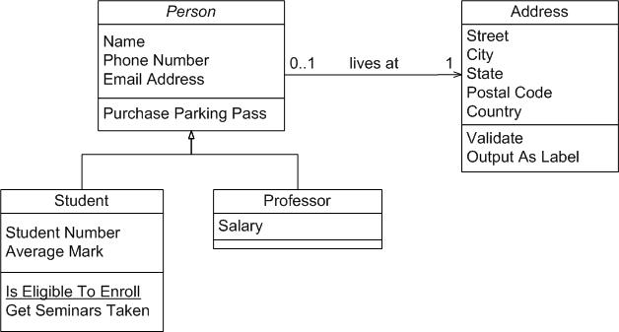

**3.5****Composition Associations**

Sometimes an object is made up of other objects. For example, an airplane is made up of a fuselage, wings, engines, landing gear, flaps, and so on. Figure 8 presents an example using composition, modeling the fact that a building is composed of one or more rooms, and then, in turn, that a room may be composed of several subrooms (you can have recursive composition). In UML 2, aggregation would be shown with an open diamond.

**Figure 8. Modeling composition.**

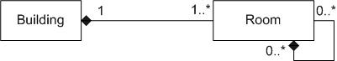

I'm a firm believer in the "part of" sentence rule -- if it makes sense to say that something is part of something else then there's a good chance that composition makes sense. For example it makes sense to say that a room is part of a building, it doesn't make sense to say that an address is part of a person. Another good indication that composition makes sense is when the lifecycle of the part is managed by the whole -- for example a plane manages the activities of an engine. When deciding whether to use composition over association, Craig Larman (2002) says it best: If in doubt, leave it out. Unfortunately many modelers will agonize over when to use composition when the reality is little difference exists among association and composition at the coding level.

**3.6****Vocabularies**

In [Agile Database Techniques (Ambler 2004)](http://www.ambysoft.com/agileDatabaseTechniques.html) I discussed the importance of vocabularies when it comes to modeling [XML data structures](http://agiledata.org/essays/advancedXML.html#Vocabularies). A vocabulary defines the semantics of entity types and their responsibilities, the taxonomical relationships between entity types, and the ontological relationships between entity types. Semantics is simply a fancy word for meaning - when we're defining the semantics of something we're defining it's meaning. Taxonomies are classifications of entity types into hierarchies, an example of which is presented for persons [Figure 9](http://www.agilemodeling.com/artifacts/classDiagram.htm#Figure9Taxonomy). Ontology goes beyond taxonomy. Where taxonomy addresses classification hierarchies ontology will represent and communicate knowledge about a topic as well as a set of relationships and properties that hold for the entities included within that topic.

**Figure 9. A taxonomy for people within the university.**

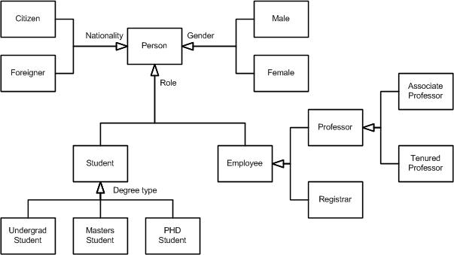

The semantics of your conceptual model are best captured in a [glossary](http://agilemodeling.com/artifacts/glossary.htm). There are several interesting aspects of [Figure 9](http://www.agilemodeling.com/artifacts/classDiagram.htm#Figure9Taxonomy):

* It takes a “single section” approach to classes, instead of the three section approach that we've seen in previous diagrams, because we're exploring relationships between entity types but not their responsibilities.
* It uses UML 2.0's generalization set concept, basically just an inheritance arrowhead with a label representing the name of the set. In UML 1.x this label was called a discriminator. There are three generalization sets for *Person*: *Nationality*, *Role*, and *Gender*.
* These generalization sets overlap - a person can be classified via each of these roles (e.g. someone can be a male foreign student). This is called multiple classification.
* You can indicate “sub generalization” sets, for example *Student* within the *Role* generalization set.
* Some generalization sets are mutually exclusive from others, not shown in the example, where an entity type may only be in one set. This is referred to as single classification and would be modeled using an XOR (exclusive OR) constraint between the two (or more) discriminators.

- See more at: http://www.agilemodeling.com/artifacts/classDiagram.htm#sthash.RlJcGXRE.dpuf